1. Write a program to reverse the String (use char[] or String built in method)

Ans)

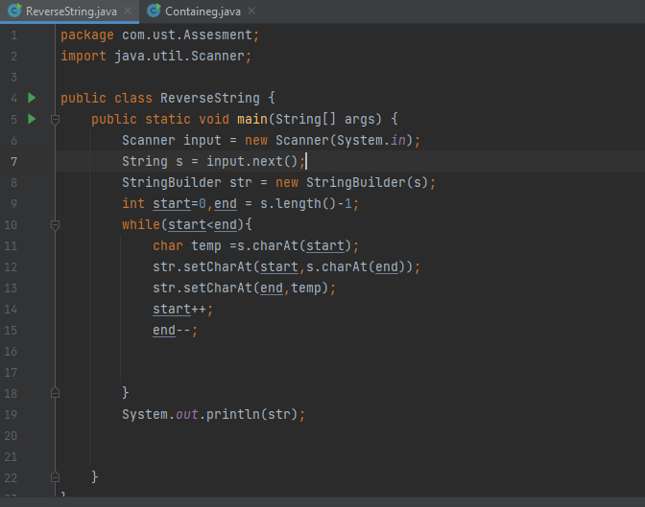

Output:

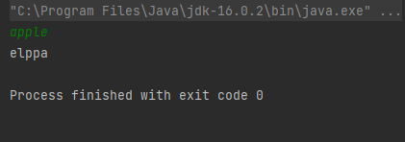

Write programs to depict the usage of contains(), length(), replace(), concat(), equals()

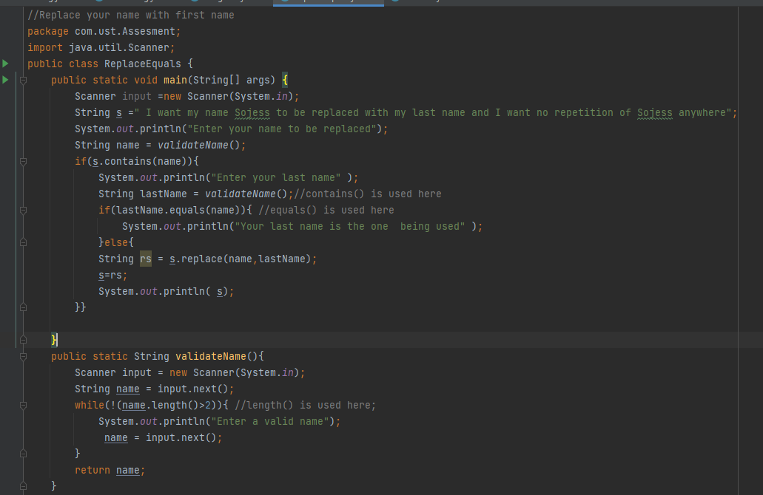

Output(contains(),replace()):

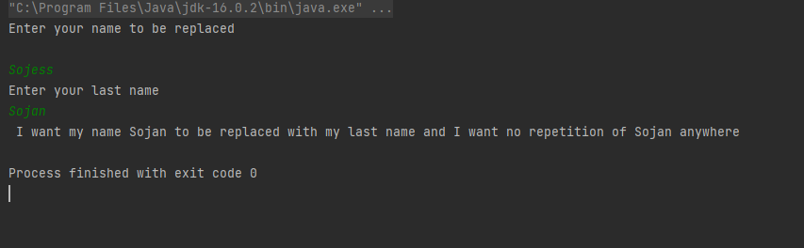

length()

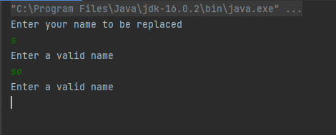

equals()

